README: Unity Assignment Bugs

I ran into several bugs during this assignment that cost me many, many hours of troubleshooting. Maybe these notes will help with any future issues other students might have as well.

1. Unrendered faces (unresolved): The robot character renders correctly in Blender (see image), but materials will not import correctly into Unity. ASeveral fixes were tried, including:
   1. Smoothing faces on the model.
   2. Changing to one or two materials instead of a third one for the robot’s “face.”
   3. Importing the model into a new project.

After several hours of attempting to fix this problem, the flawed model was simply used in the Unity project; the character appears with several large gaps in its head. The issue seems to affect certain extruded faces in all forms of the model. Also, the materials attached to the erroneous faces would not import with the model using any technique of export/import, including importing the entire .blend file directly into Unity.

1. Cannot attach scripts to objects due to class name errors (resolved): A particular script for the “Goal” materials was not attaching. Unity continued to generate errors that the class name did not match the script. After attempts to bug check, recreate, and rename the script, a solution was finally found by copying the script to the desktop, deleting it from the Assets folder, and then importing it as an external asset.

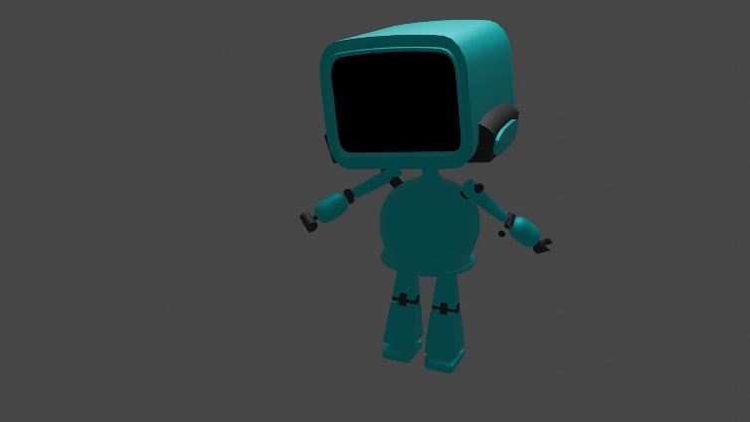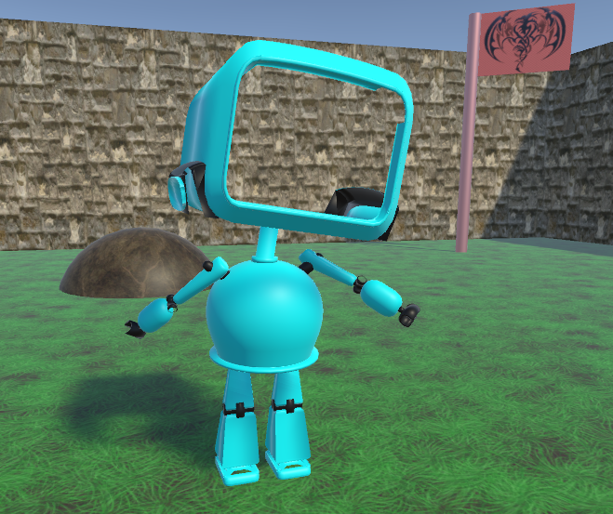

Top: Blender render

Bottom: Unity scene